Pokhara University

Level: Bachelor | Semester – Spring | Year : 2008
Programme: BE |  | Full Marks: 100
Course: Engineering Mathematics III |  | Time : 3hrs.

Candidates are required to give their answers in their own words as far as practicable.
The figures in the margin indicate full marks.

Attempt all the questions.

 | - Define inverse of a matrix. Let A and B be two matrices of specified order, then show that (AB)⁻¹ = B⁻¹ A⁻¹ where A and B are non-singular matrix.  - Define rank of the matrix. Find rank of the matrix BA where A = (1 2 -1) and B = 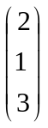  OR  Show that 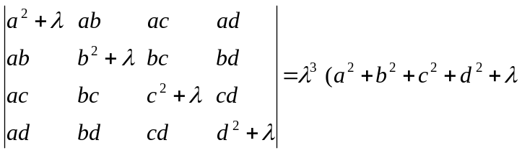) | 7  8  8
 | - Define consistency of the system of linear equations. Solve the given system of linear equations x + 3y + 6z = 2 3x – y + 4z = 9, x – 4y +2z = 7 by using Gauss Elimination methods.  - Find the Eigen value and Eigen vector of the matrix  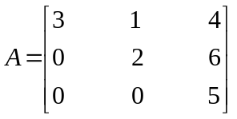 | 8  7
 | - Define directional derivative of the function f(x) in the direction . Find directional derivative of f = xy² + yz³ at (2, -1, 1) along the direction of the normal to the surface S:  x log z – y² + 4 = 0 at (-1, 2, 1).  OR  Define Divergence and Curl of a vector function. If f be a continuous and differentiable scalar valued function then prove that curl (grad f) = 0  - Find the work done by the force 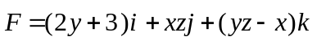, when it moves a particle from the point (0, 0, 0) to (2, 1, 1) along the curve x = 2t², y = t, z = t³. | 8  8  7
 | - State Green's theorem and use it to evaluate the integral 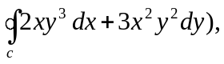c : x² + y² = 1 counter clockwise.  - Evaluate 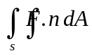 where  OR  State Stokes theorem. Evaluate 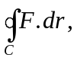 where 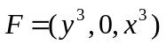and C is the boundary of the triangle with vertices (1, 0, 0), (0, 1, 0) and (0, 0, 1). | 7  8  8
 | - Show that the necessary condition for an infinite series 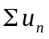to be convergent is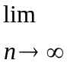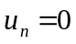. Give an example that above condition is not sufficient for the series to be conversant.  - Find the interval and radius of convergence of power series. 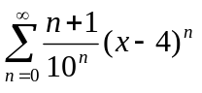  OR  Expand 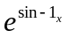by Maclaurin series up to four terms | 8  7  7
 | - Define periodic function with suitable example. Find the fourier series of the periodic function f(x) = x² for – π < x < π. Using it show that 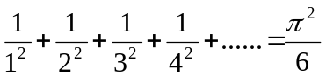.  - Find fourier sine as well as cosine series of the function f(x) = x for 0 < x < π. | 8  7
 | - Show that vectors (1, 0, 0), (0, 1, 0) and (0, 0, 1) are linearly independent.  - Test the convergence or divergence of series 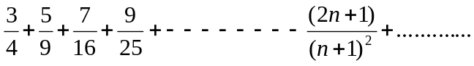  - Find the period of f(x) = cos2x  - Find the unit vector normal to surface x²y + 2xz = 4 at (2, -2, 3)  - Find the divergence of the vector 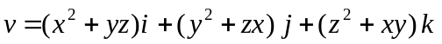 | 5×2

